Where should my files go?

In demos and programming assignments, you will be asked to download notebooks and datasets. This guide will show you where to place those files, so that IPython notebook can find them.

This guide assumes that you are using the GraphLab Create Launcher.

1. Launch the GraphLab Create Launcher.

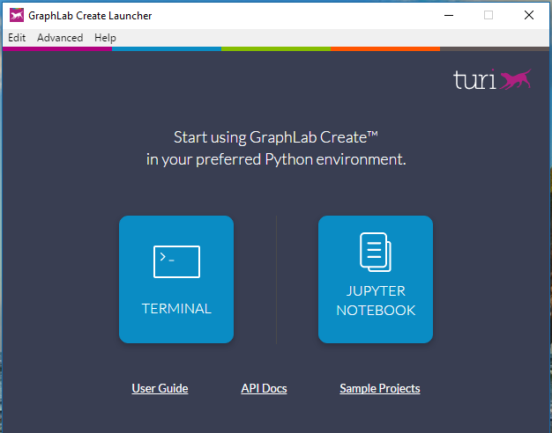

2. Click "IPYTHON NOTEBOOK" to launch IPython notebook. You will be greeted with the main page:

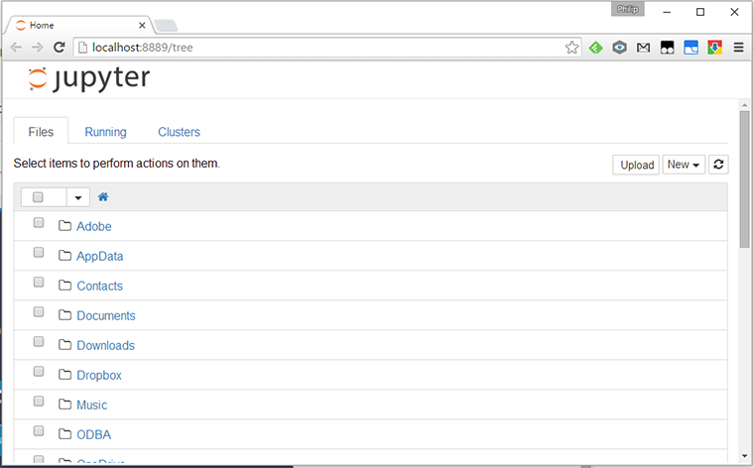

3. From the top right, find the button labeled "New▾". Click the button to get a drop-down menu, and select "Python 2" under the sub-heading "Notebooks." This should create a new notebook inside the home directory of IPython notebook.

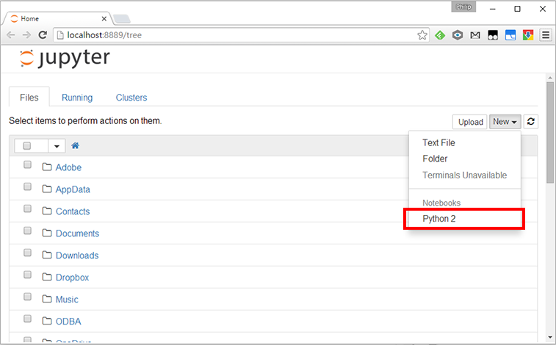

4. In the new notebook, run

to obtain the full path of the home directory of IPython notebook. This path is where your files should go. Highlight the path and copy it.

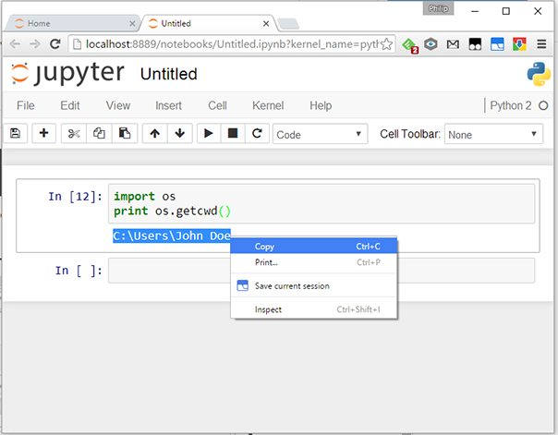

5. Place any files (notebooks and datasets) under the home directory. You may organize your files using sub-folders.

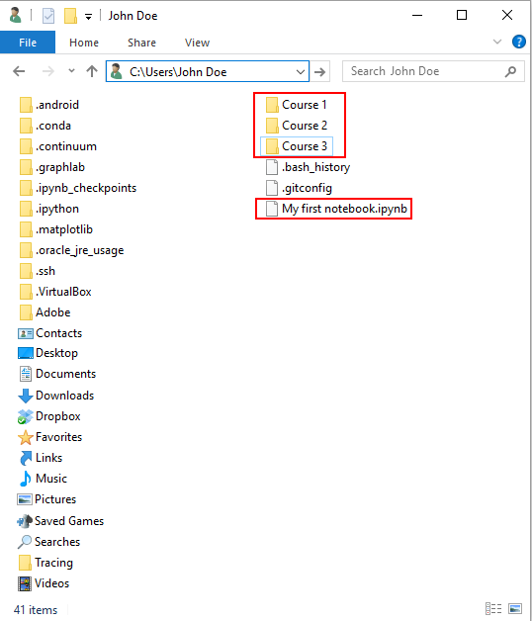

6. All files and folders placed inside the home folder will appear in the main page:

